**THERMAL MODELING OF A CYCLINDERICAL LITHIUM-ION BATTERY IN 3D WITH COMSOL**

**Modelling 1D lithium-ion battery**

This model demonstrates the Lithium-Ion Battery interface for studying the discharge and charge of a lithium-ion battery for a given set of material properties. The geometry is in one dimension and the model is isothermal. Battery designers can use the model to investigate the influence of various design parameters such as the choice of materials, dimensions, and the particle sizes of the active materials — in this case, a carbon material in the negative electrode and lithium manganese oxide (LiMn2O4 spinel) in the positive electrode. You can also benefit from simulating battery performance under different operating conditions and in different devices, for example, cell phones or laptop computers.

The model includes the following processes:

• Electronic current conduction in the electrodes

• Ionic charge transport in the electrodes and electrolyte/separator

• Material transport in the electrolyte, allowing for the introduction of the effects of concentration on ionic conductivity and concentration overpotential, which in this case are obtained from experimental data

• Material transport within the spherical particles that form the electrodes

• Butler–Volmer electrode kinetics using experimentally measured discharge curves for the equilibrium potential

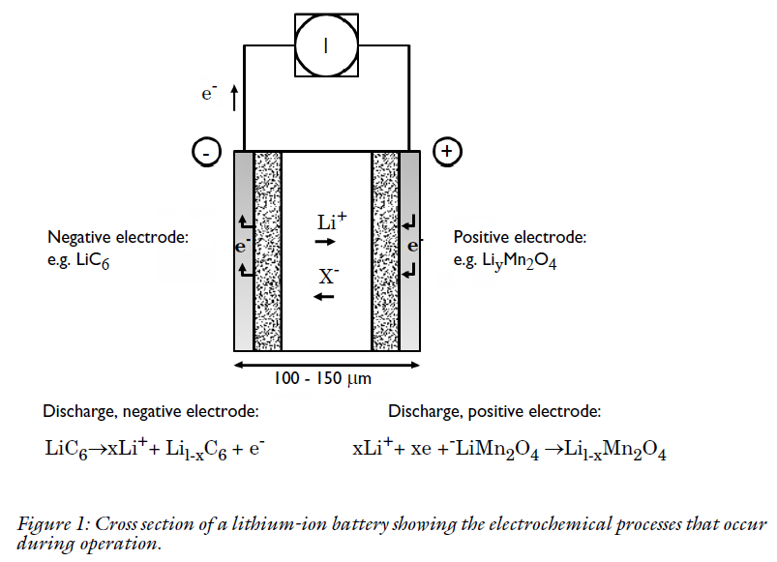

**BOUNDARY CONDITIONS**

For the electronic current balance, a potential of 0 V is set on the negative electrode’s current collector/feeder boundary. At the positive electrode current collector/feeder, the current density is specified. In this model, the current density is cycled through a discharge, followed by an interval of zero current, and a final charging stage. The inner boundaries facing the separator are insulating for electric currents. For the ionic charge balance in the electrolyte, the current collector/feeder boundaries are insulating. Insulation boundary conditions also apply to the material balances. At the particle surface in the local particle model, the material flux is determined by the local electrochemical reaction rate.

**MATERIAL PROPERTIES**

The material properties are those of a typical lithium-ion battery. The electrolyte consists of 2 M LiPF6 salt in 1:2 EC: DMC (by volume) solvent and p(VDF-HFP). The electrode materials are carbon-based material for the negative electrode and Li*y*Mn2O4 for the positive electrode. The electrolyte conductivity and the equilibrium potential of the negative and positive electrodes are composition dependent as given by experimentally measured data. This data is either taken from the Material Library, or tabulated in interpolating functions in the model. The properties vary significantly during the charge and discharge phases due to the changes in composition.

**RESULTS**

**DISCHARGE CURVES**

The battery is initially at a fully charged state. A first modelling approach is to simulate discharge at various current densities and then display the discharge curves. The results show the capacity of the battery at different discharge rates. The end-of-discharge is reached when the cell voltage drops below 3 V. The nominal discharge current density, corresponding to the 1 C case below, is 17.5 A/m2. The 1 C rate corresponds to a theoretical full discharge in one hour.

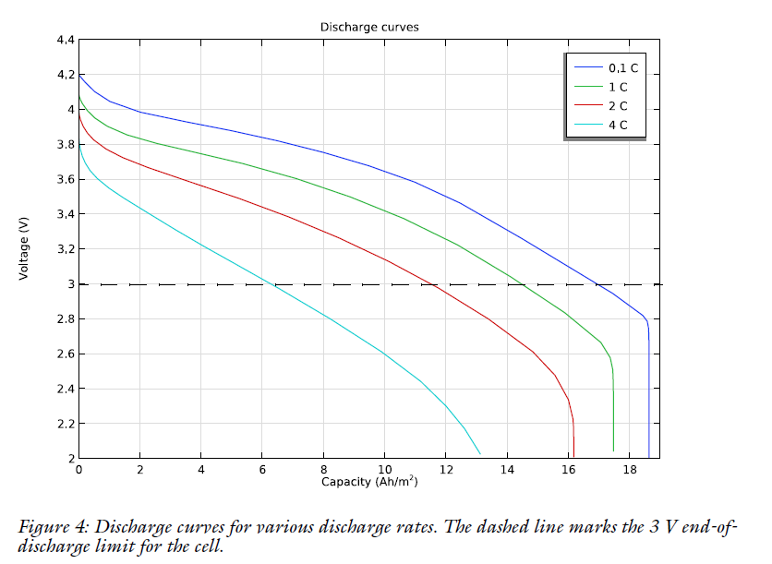

**DISCHARGE AND CHARGE CYCLE**

Figure depicts the discharge-charge cycle applied in the next step of the simulation. The cycle applies 2000 s of discharge at nominal current density (case 1C above), 300 s at open circuit, then 2000 s of charge at nominal current density, and finally open-circuit conditions.

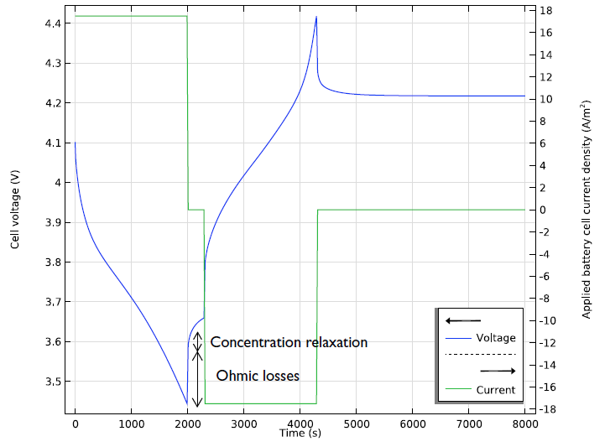

**THERMAL MODEL**

The thermal model is made in 3D using the Heat Transfer in Solids and Fluids interface. The geometry (see Figure) consists of the following domains:

* Active battery material domain (wound sheets of cell material, 65 mm high, radius9 mm)
* Mandrel (nylon isolator around which the battery cell sheets are wound, 2 mm radius)
* Cylindrical battery connector on top of the battery (steel, 3 mm thick)
* Flow compartment (air)

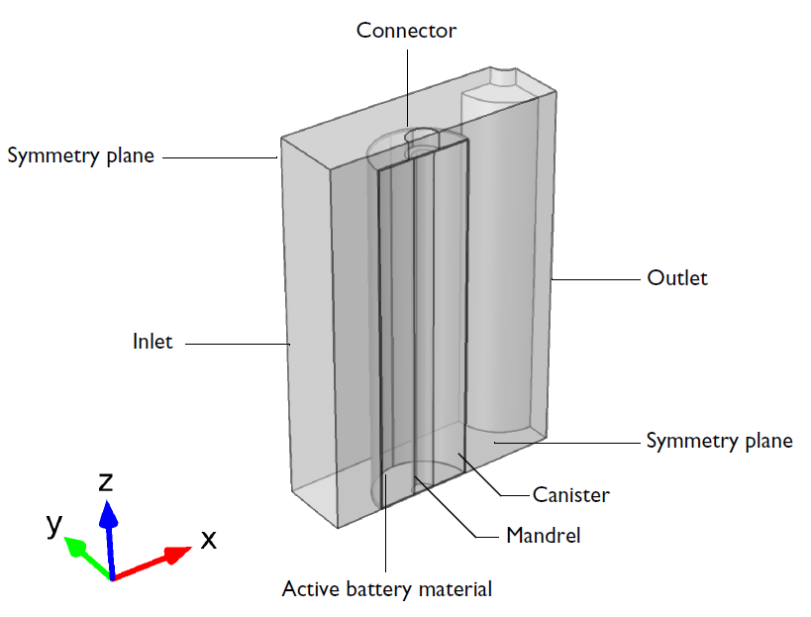

The battery canister (0.25 mm thick) is not included as a domain in the geometry, since the effect of the steel canister on the temperature profile are small, as can be seen in the Thermal Modelling of a Cylindrical Lithium-Ion Battery in 2D model. The heat source term in the active battery material domain is however scaled to account for the lack of heat generation in the current collectors, and for the canister thickness. This scaled heat source is obtained by multiplying the volumetric heat source from the 1D Li-ion battery model by two factors. The first factor is the fraction of the total 1D model in which heat is generated. That is the sum of lengths of the negative electrode, separator and the positive electrode, divided the total cell length, which also includes the lengths of the two current collectors. The second factor is the fraction of the total 3D cylindrical cell geometry in which heat is generated. The volume in which heat is generated is the total volume of the cell (which includes both the homogenized wound layers of the battery material, the central mandrel and the outer can), minus the volume of the mandrel and the volume of the outer can. This heat source is then divided by the total volume of battery material, which is the difference between the total cell volume and the mandrel volume.

**RESULT**

The temperature in the battery and streamlines for the flow at 1500 s. The temperature maximum is located in the active battery material toward the thermally isolated end.

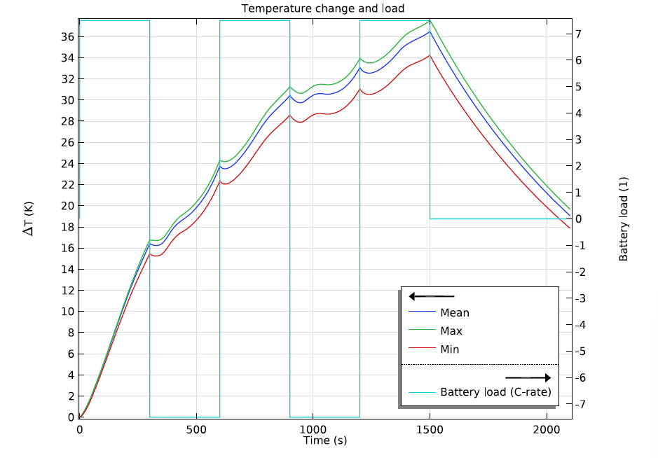

Next Figure shows the difference in battery temperature and airflow streamlines between the coupled solution and the one-way solution. The differences are calculated using a Join dataset. In this case, the one-way solution is very similar to the coupled one, since only the fluid viscosity is temperature-dependent. The details of the flow pattern do change, but with a magnitude that is only a few percent of the total fluid flow velocity. The one-way calculation completes in a fraction of the time that the coupled calculation requires. This usage of the Nonisothermal Flow multiphysics feature in a one-way study to compute flow,

heat, and the battery electrochemistry illustrates one key simplification that might be used in many thermal battery models. At the same time, checking the assumption is simple.

